- Purpose
  - The purpose of this document is to describe the procedure for assembling the bearing on an orbital Genesys machine.
- Scope
  - This SOP applies to all equipment assembly team members. The process applies to the following ID’s:
EP50322EQS0600BE1200 – Orbital Head Assembly (MSAS)
EP50291EQS0600BE1200 – Orbital Head Assembly (G20)
- Responsibilities
  - The operations manager/supervisor is responsible for enforcing this SOP.
- Materials
  - The proper materials needed for this process are listed on the machine work order.
- Definitions

- Procedure
  - Start with an orbital bearing hub (E28525). Apply green Loctite to inside of the bearing hub. Press a bearing (E28524) into the hub using the tool provided. For this step, the “B” side of the tool should be facing down. This will ensure the tool is in the proper orientation so that it contacts to outer race of the bearing. Make sure the bearing is square to the housing prior to pressing. Once the bearing hits the shoulder of the hub, do not press any more.
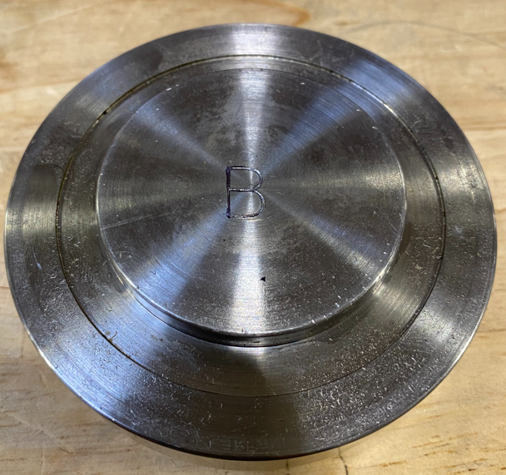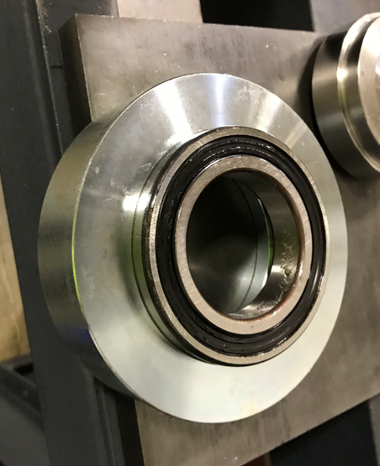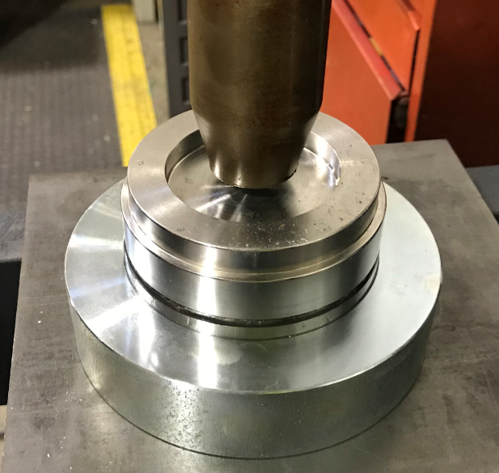
  - Take the installation tool and place it under the bearing assembly so that the bearing sits on it. The “C” side of the tool should be facing up. Ensure that it is in the proper orientation (as shown). The tool will support the inner race of the bearing.
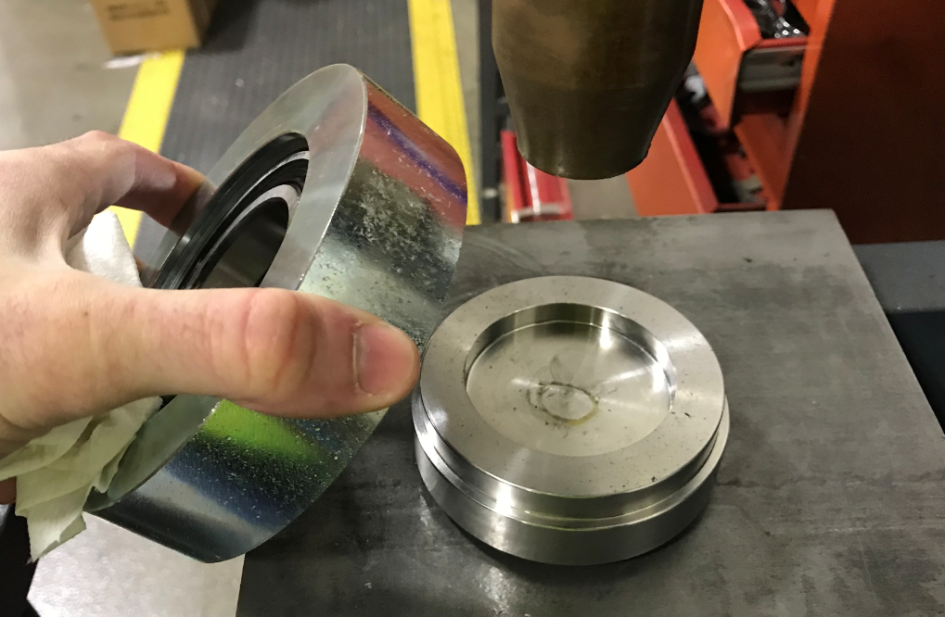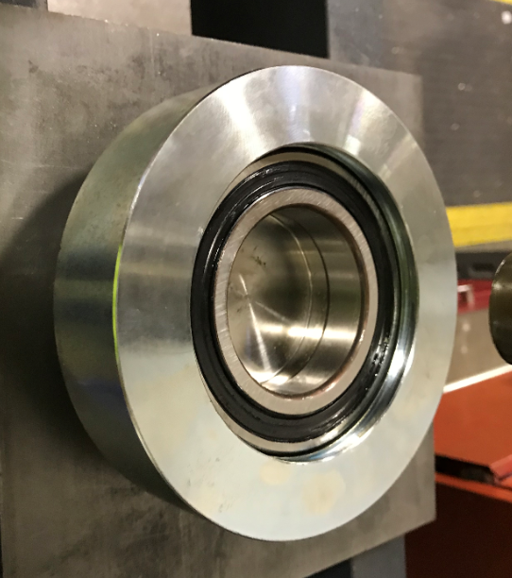
  - Press an eccentric bearing hub (E28522 for MSAS / E29025 for G20) into the bearing. Once the shoulder on the hub hits the bearing, do not press any more. Remove the assembly. Ensure the bearing spins easily.
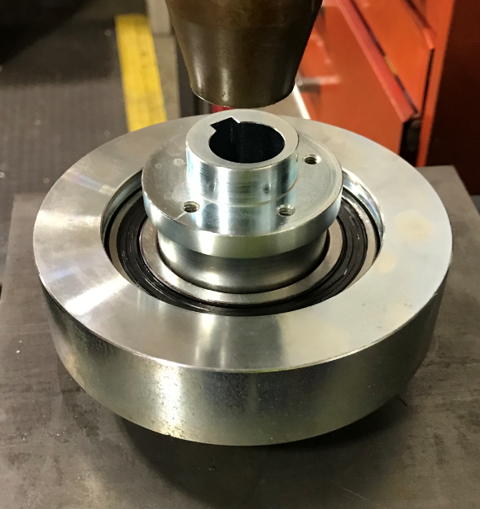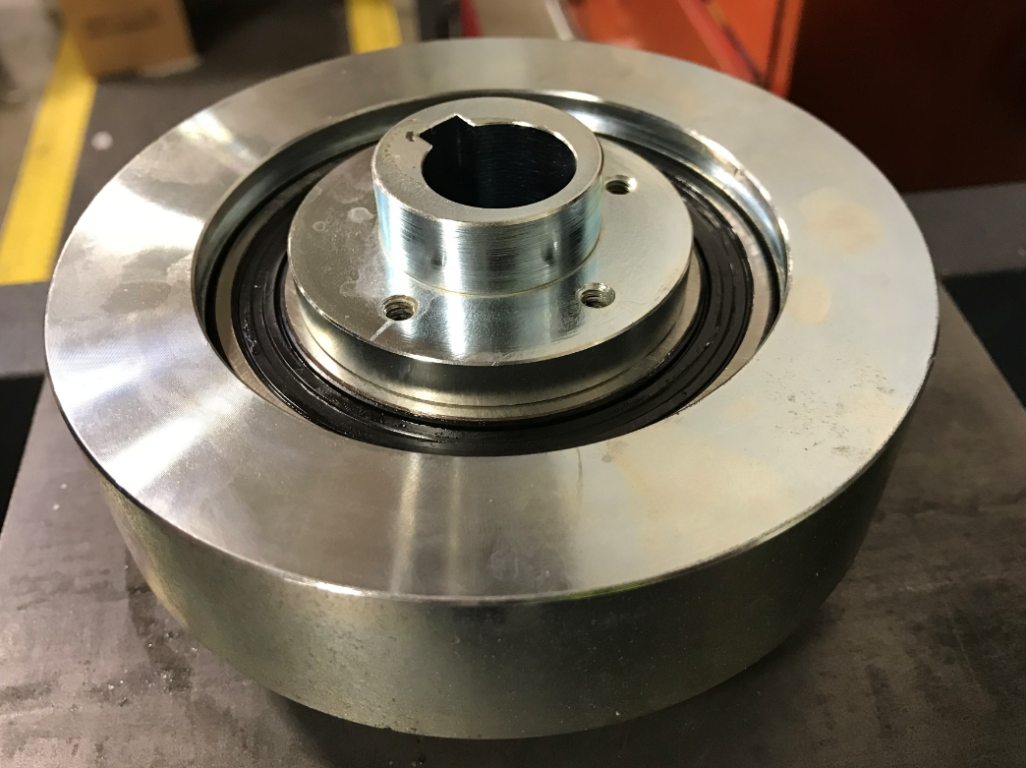

  - Install an ID snap ring (E28632) into the bearing hub. Ensure it is properly seated in the groove all the way around.

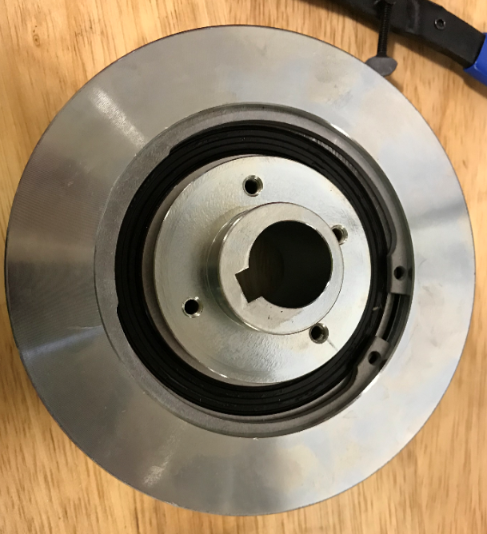

  - Install an OD snap ring (E28529) onto the bearing hub. Ensure it is properly seated in the groove all the way around.

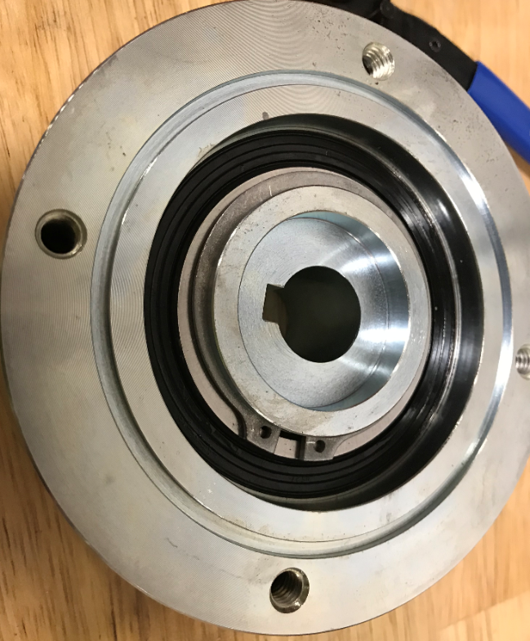

  - Attach the orbital counterweight bracket (E28523 for MSAS / G20 for E28009) using 4 screws (E29431). Use blue Loctite on the threads.
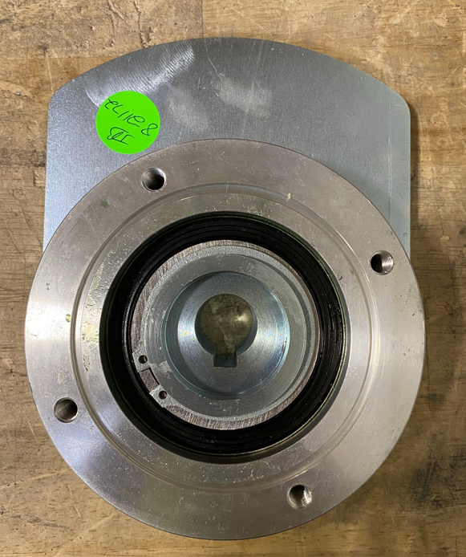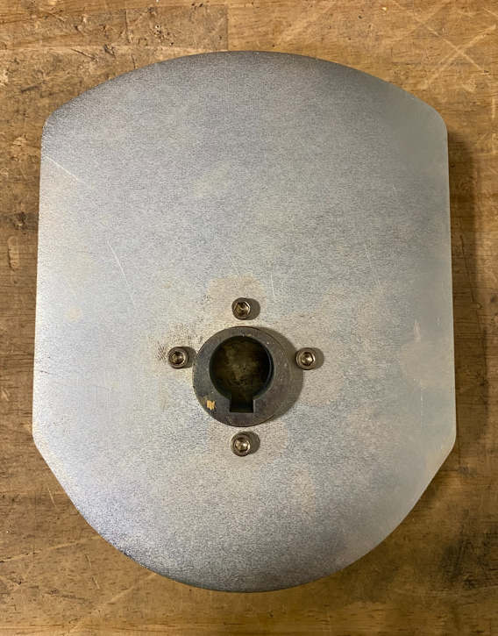
- References (optional section as needed)

- Training Guide

Functional Training Groups Requiring Training
Equipment Assembly Group

- SOP Change Control

Date of Change | Reason for Change
Rev 01 | This is the first version of the S.O.P. hence there are no revisions to this document.
Rev 02 - 8/13/2021 | Added QC Check notes. Updated for new counterweight
Rev 03 - 3/31/2025 | Combined MSAS and G20 instructions and updated

Approvals

Submitter/Author Approval:__________________________________ Date:______________________

Management Approval:______________________________________ Date:______________________

QAU Approval:_____________________________________________ Date:______________________

